Answer 1

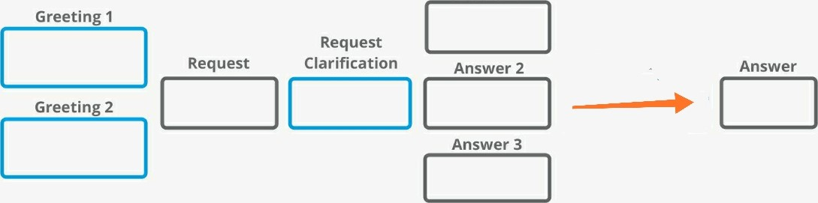

User Accepts Confirmation Approval End

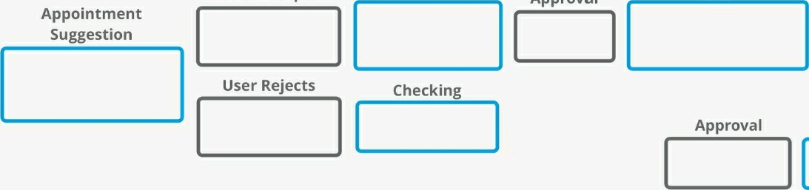 End